**PRACTICAL – 6**

**AIM:**

**Add the 16-bit number in memory locations 4000H and 4001H to the 16-bit number in memory locations 4002H and 4003H. The most significant eight bits of the two numbers to be added are in memory locations 4001H and 4003H. Store the result in memory locations 4004H and 4005H with the most significant byte in memory location 4005H.**

**CODE:**

ORG 100H

MOV [4000H],5050H

MOV [4002H],2020H

MOV AX,[4000H]

MOV BX,[4002H]

ADD AX,BX

MOV [4004H],AX

RET

**OUTPT:**

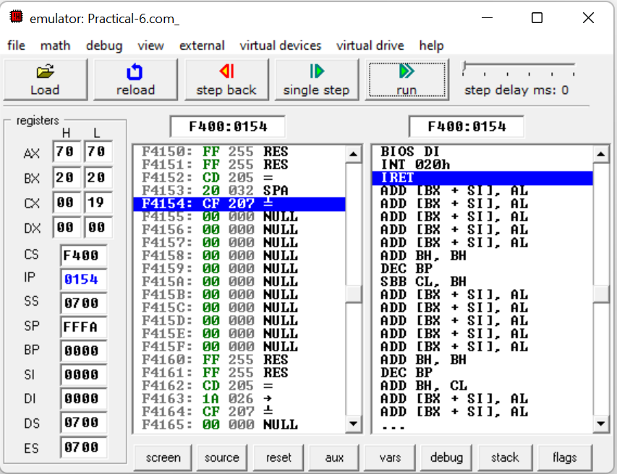

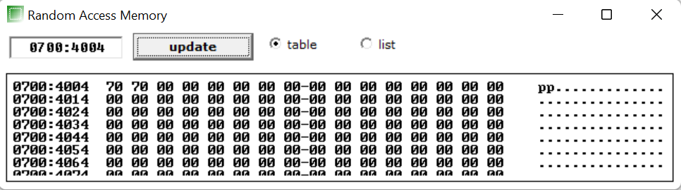

**CONCLUSION:**  In this practical we learnt how to add 16 bit number in memory location.